Lab Exercise 16- Creating a ConfigMap from a Folder

In this lab exercise, you will learn how to create a ConfigMap in Kubernetes from a folder containing multiple files. This allows you to manage multiple configuration files as a single ConfigMap.

Step 1: Set Up Kubernetes Cluster

Ensure you have access to a Kubernetes cluster. You can use a local setup with Minikube, kind, or use a cloud-based Kubernetes service.

Output: - (for starting kubernetes)
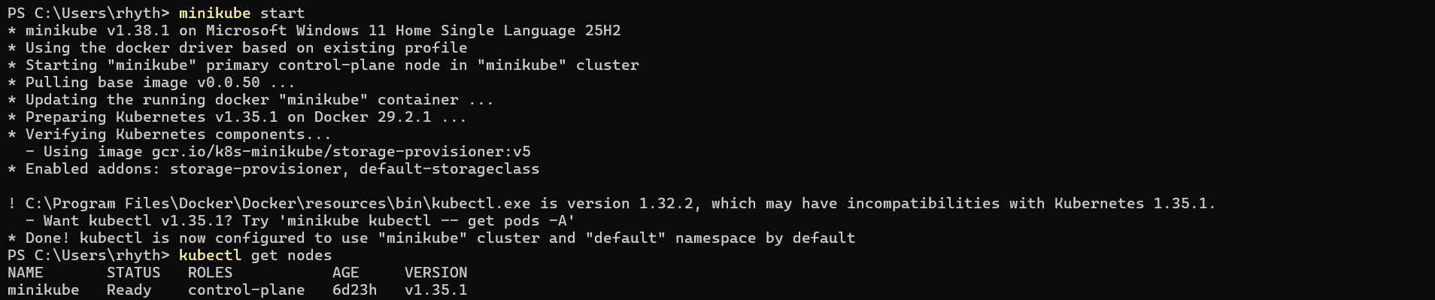

Step 2: Prepare the Folder with Multiple Files

Create a directory named configmap-folder:

mkdir configmap-folder
cd configmap-folder/

‘
Output: -
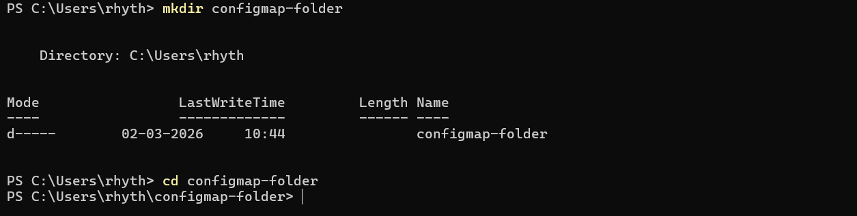

Create multiple configuration files inside the directory:

Output: -

config1.txt with content:
key1=value1

Output: -
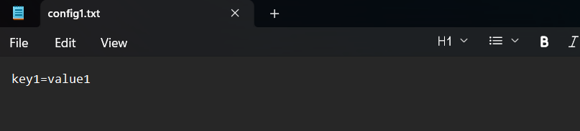

config2.txt with content:
key2=value2

Output: -
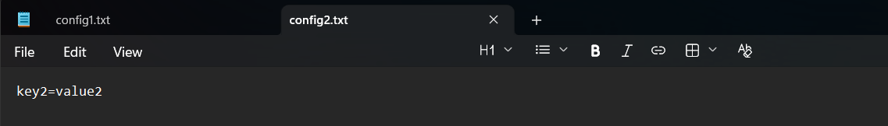

config3.txt with content:

key3=value3

Output: -
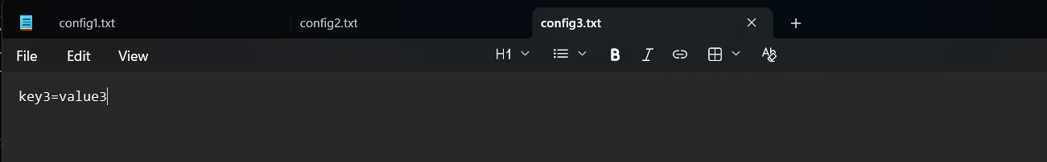

Verify the directory structure:

ls configmap-folder/
cd ..

You should see the files config1.txt, config2.txt, and config3.txt.

Output: -
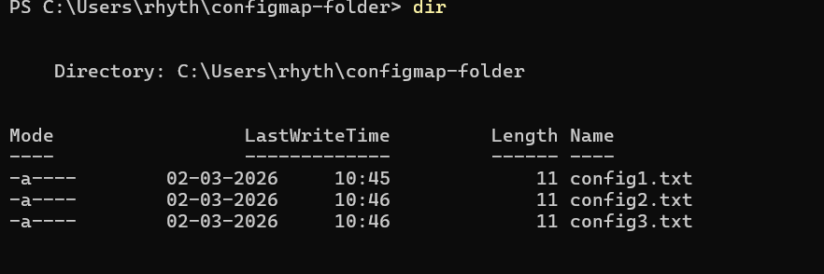

Step 3: Create a ConfigMap from the Folder

Create a ConfigMap named folder-configmap from the folder:

kubectl create configmap folder-configmap --from-file=configmap-folder/

Output: -

Verify the ConfigMap:

kubectl get configmap folder-configmap -o yaml

You should see the folder-configmap with the contents of all the files in the configmap-folder.

Output: -
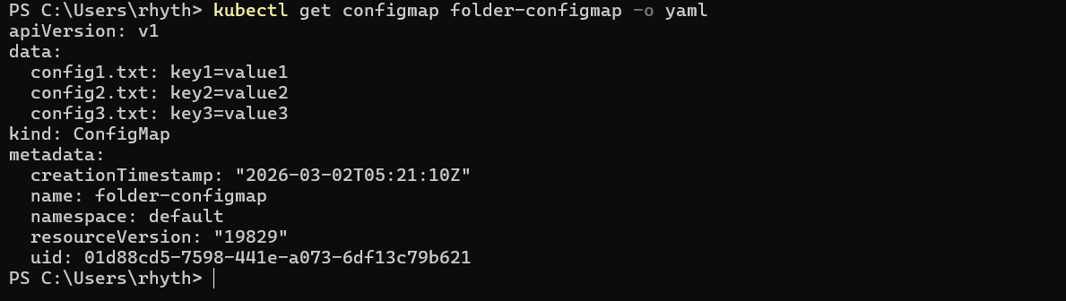

Step 4: Use the ConfigMap in a Pod

Create a file named pod-folder-configmap.yaml with the following content:

apiVersion: v1
kind: Pod
metadata:
name: configmap-pod
spec:
containers:
- name: nginx
image: nginx
envFrom:
- configMapRef:
name: folder-configmap

Output: -

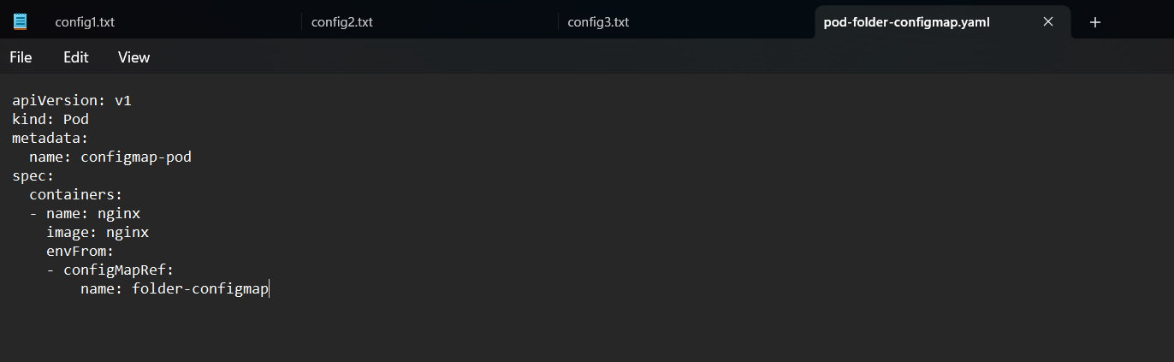

In this manifest:

- The Pod mounts the folder-configmap at /etc/config.
- The busybox container concatenates and prints the contents of the files.

Apply the manifest to create the Pod:

kubectl apply -f pod-folder-configmap.yaml

Output: -

Check the status of the Pod:

kubectl get pods
‘
Output: -
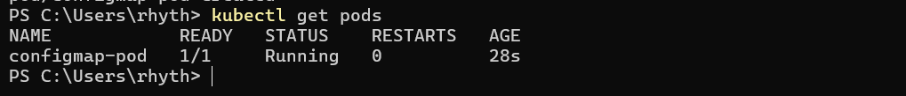
View the Pod logs to see the content of the mounted files:

kubectl exec -it configmap-pod -- printenv

You should see the contents of config1.txt, config2.txt, and config3.txt printed.

Output: -
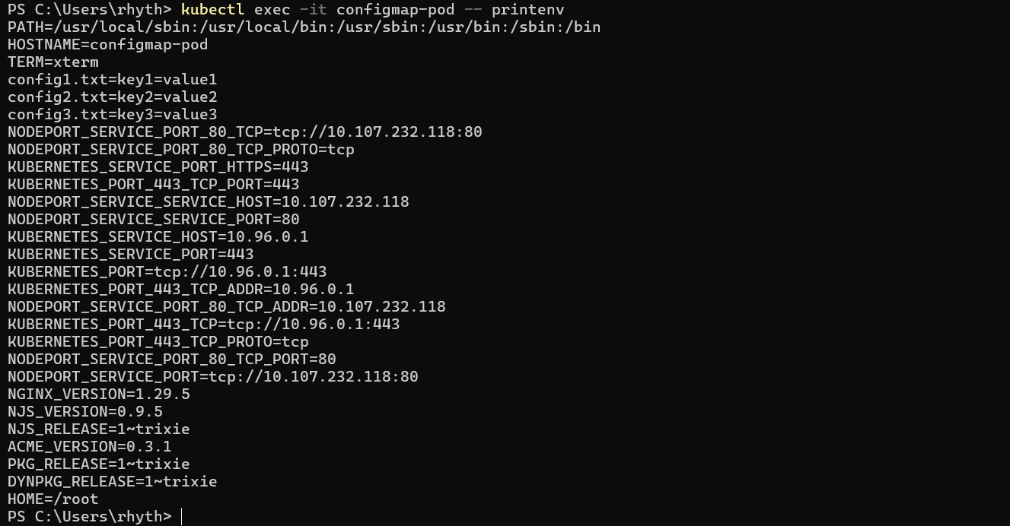

Step 5: Clean Up

After completing the exercise, clean up the resources created:

kubectl delete pod folder-configmap-pod
kubectl delete configmap folder-configmap
rm -r configmap-folder

Output: -
